Ilan Weinschelbaum
Assignment #9
Exercise 2:
time_step = 0.1, final time =1
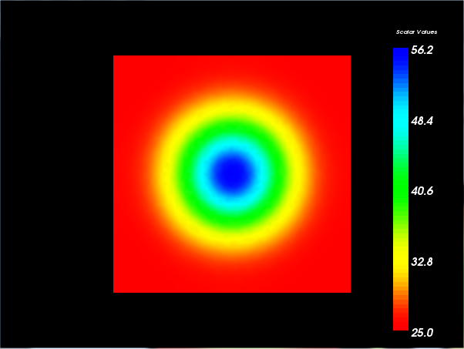

time_step = 0.1, final time = 10
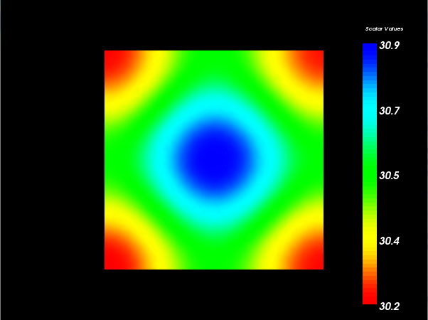

Exercise 3:
